**Ultrasonic Distance Sensor HC-SR04**

[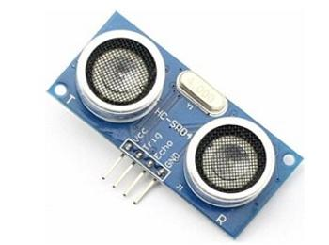](http://www.simplelabs.co.in/sites/default/files/hcsr04_szd_0.jpg)

* Price: Rs.525.00 including Taxes

|  |
| --- |
|  |

**Description**

The HC SR04 is an inexpensive ultrasonic distance sensor.  
Specifications:  
power supply :5V DC  
quiescent current : <2mA  
effectual angle: <15°  
ranging distance : 2cm – 500 cm  
resolution : 0.3 cm  
Works with Arduino

**Sample Arduino Code**  
/* HC-SR04  
A Simple Modified version of the Ping Sensor Program t

*/

// this constant won't change. It's the pin number  
// of the sensor's output / trigger  
const int echo = 8, Trig = 9;

void setup() {  
// initialize serial communication:  
Serial.begin(9600);  
pinMode(Trig, OUTPUT);  
pinMode(echo, INPUT);  
}

void loop()  
{  
// establish variables for duration of the ping,  
// and the distance result in inches and centimeters:  
long duration, inches, cm;

// The PING))) is triggered by a HIGH pulse of 10 microseconds.  
// Give a short LOW pulse beforehand to ensure a clean HIGH pulse:

digitalWrite(Trig, LOW);  
delayMicroseconds(2);  
digitalWrite(Trig, HIGH);  
delayMicroseconds(10);  
digitalWrite(Trig, LOW);

// The echo pin is used to read the signal from the PING))): a HIGH  
// pulse whose duration is the time (in microseconds) from the sending  
// of the ping to the reception of its echo off of an object.

duration = pulseIn(echo, HIGH);

// convert the time into a distance  
inches = microsecondsToInches(duration);  
cm = microsecondsToCentimeters(duration);

Serial.print(inches);  
Serial.print("in, ");  
Serial.print(cm);  
Serial.print("cm");  
Serial.println();

delay(100);  
}

long microsecondsToInches(long microseconds)  
{  
// According to Parallax's datasheet for the PING))), there are  
// 73.746 microseconds per inch (i.e. sound travels at 1130 feet per  
// second). This gives the distance travelled by the ping, outbound  
// and return, so we divide by 2 to get the distance of the obstacle.  
return microseconds / 74 / 2;  
}

long microsecondsToCentimeters(long microseconds)  
{  
// The speed of sound is 340 m/s or 29 microseconds per centimeter.  
// The ping travels out and back, so to find the distance of the  
// object we take half of the distance travelled.  
return microseconds / 29 / 2;  
}